LAB 4

1.

package com.company;  
import java.util.Scanner;  
import java.util.Arrays;  
class billing{  
 double p, q, c;  
 double compbil(double price){  
 p=price;  
 p=(p*0.08)+p;  
 return p;  
 }  
 double compbil(double price, double qty){  
 p=price;  
 q=qty;  
 p=p*q;  
 p=(p*0.08)+p;  
 return p;  
 }  
 double compbil(double price, double qty, double coupon){  
 p=price;  
 q=qty;  
 c=coupon;  
 p=(p*q)-c;  
 p=(p*0.08)+p;  
 return p;  
  
 }  
}  
public class Main{  
 public static void main(String[] args){  
 Scanner n=new Scanner(System.*in*);  
 double res, coupon, price, qty ;  
 System.*out*.println("Price: ");  
 price= n.nextInt();  
 System.*out*.println("Qty: ");  
 qty= n.nextInt();  
 System.*out*.println("Coupon: ");  
 coupon= n.nextInt();  
  
 billing bil= new billing();  
 res=bil.compbil(price);  
 System.*out*.println("Price(tax addition): "+res);  
 res=bil.compbil(price, qty);  
 System.*out*.println("Price(Qty, tax addition): "+res);  
 res=bil.compbil(price, qty, coupon);  
 System.*out*.println("Price(Coupon, tax addition): "+res);  
  
 }  
}

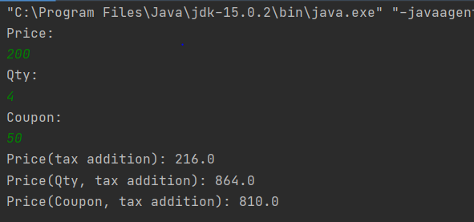

2.

package com.company;  
  
  
public class testpatient extends patient {  
 public static void main(String[] args){  
 patient P = new patient();  
 patient P1 = new patient(1,23,true);  
 patient P2 = new patient(2,12,false);  
 P.display();  
 P1.display();  
 P2.display();  
 }  
}

package com.company;  
import java.util.Scanner;  
import java.util.Arrays;  
public class patient{  
 int id,age,blooddata;  
 patient(){  
 id=age=blooddata=0;  
 }  
 patient(int a,int b,boolean c)  
 {  
 id=a;  
 age=b;  
 blooddata= c ? 1 : 0;  
 }  
 public void display()  
 {  
 System.*out*.println(id+" "+age+" "+blooddata);  
 }  
}

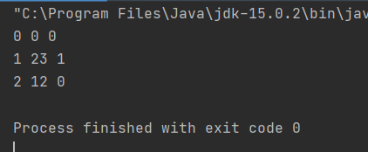

3.

package com.company;  
import java.util.Scanner;  
import java.util.Arrays;  
public class Main{  
 public static void julday(double julno){  
 String day[]={"Sunday","Monday","Tuesday", "Wednesday", "Thursday", "Friday", "Saturday"};  
 julno=(julno+1)%7;  
 for(int i=0; i<=6; i++){  
 if(julno==i){  
 System.*out*.println("The day is a "+day[i]);  
 }  
 }  
 }  
 public static void main(String[] args){  
 Scanner n=new Scanner(System.*in*);  
 double julno, res;  
 System.*out*.println("Enter Julian day number: ");  
 julno= n.nextInt();  
 *julday*(julno);  
 }  
}

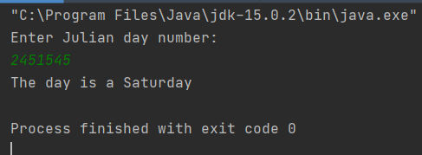

4.

package com.company;  
import java.util.Scanner;  
import java.util.Arrays;  
class shirt{  
 int size, sleeve;  
 String mat;  
 shirt(int size, int sleeve){  
 this.size =size;  
 this.sleeve=sleeve;  
 mat="Cotton";  
  
 }  
 void display(){  
 System.*out*.println("Size: "+size+"\n"+"Sleeve: "+sleeve+"\n"+"Material: "+mat);  
 }  
}  
public class Test_shirt{  
 public static void main(String[] args){  
 Scanner n=new Scanner(System.*in*);  
 int size, sleeve;  
 System.*out*.println("Size: ");  
 size= n.nextInt();  
 System.*out*.println("Sleeve: ");  
 sleeve= n.nextInt();  
 shirt s= new shirt(size, sleeve);  
 s.display();  
  
 }  
}

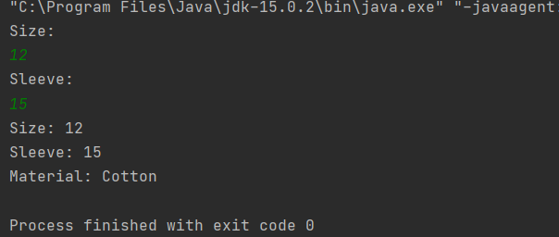

5.

package com.company;  
import java.util.*;  
  
public class UseTaxPayer{  
 public static void main(String[] args){  
 Scanner in = new Scanner(System.*in*);  
 int SSN, gi;  
 int[] ssn= new int[10];  
 int[] gross = new int[10];  
 System.*out*.println("Enter values for Taxpayers(5):\n ");  
 for(int i = 0;i<5;++i){  
 System.*out*.print("SSN: ");  
 SSN = in.nextInt();  
 System.*out*.print("Gross Income: ");  
 gi = in.nextInt();  
 Taxpayer obj = new Taxpayer(SSN, gi);  
 ssn[i] = obj.get_SSN();  
 gross[i] = obj.get_gi();  
 }  
 System.*out*.println("Taxpayer Details: ");  
 for(int i = 0;i<5;++i){  
 System.*out*.println("SSN : " + ssn[i] + " Gross income : " + gross[i] + "\n");  
 }  
 }  
}

package com.company;  
public class Taxpayer{  
 int SSN, gi;  
 public Taxpayer(int SSN, int gi){  
 this.SSN = SSN;  
 this.gi = gi;  
 }  
  
 public int get_SSN(){  
 return SSN;  
 }  
  
 public int get_gi(){  
 return gi;  
 }  
}

